Logic Circuits

Basics
- A Logic Gate simulator can be downloaded from http://logic.ly/download/ or you can use the browser version at http://logic.ly/demo/ .

- Create this Logic Circuit

A | B | X
Off (0) | Off (0)
Off (0) | On (1)
On (1) | Off (0)
On (1) | On (1)
- Turn the switches on and off and see what happens. A clue is the name given to the shape in the software.
Complete the Truth Table below.

A | B | X
0 | 0
0 | 1
1 | 0
1 | 1
- Now do the same for this circuit.
A | X
0
1
- Do the same for this one
 | Gate Name | Description of output
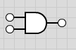
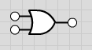
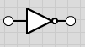
- What are the names given to these logic gates?

Combining Gates

A | B | C | X  = NOT(A AND B)
- Make these circuits and create TRUTH TABLES for each one.
A | B | C | X = NOT(A OR B)
- 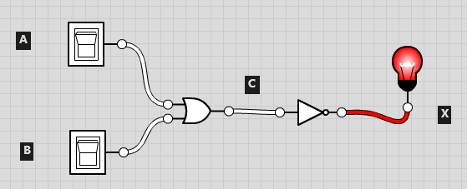
A | B | C = A OR B | X = (A OR B) AND B
- 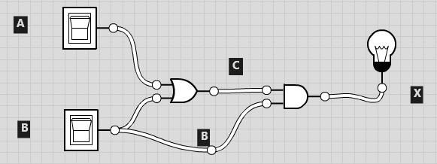
A | B | C  = A OR B | D  = NOT (A OR B) | E  = NOT B | X = D AND E  = NOT (A OR B) AND (NOT B)
- 